

**Request for Proposal (RFP)**

**Draft (V0.1)**

**Community Fibre Ltd.**

**2 Eastbourne Terrace, Paddington,**

**London W2 6LG**

**20-03-2018**

**Table of Contents**

1. Introduction and solicitation requirements 3

**1.1 Introduction** 3

**1.1.1 Contract Term and Specifications** 3

**1.1.2 Questions** 3

**1.1.3 Terminology** 3

**1.2** **Solicitation Requirements** 4

**1.2.1 RFP Process** 4

**1.2.2 Basis for Award.** 5

**1.2.3 Errors and Omissions Regarding the RFP.** 5

**1.2.4 Addenda to the RFP.** 5

**1.2.5 Submission of the RFP.** 5

**1.2.6 Submission of Proposals.** 6

**1.2.7 Vendors' Costs** 6

**1.2.8 Rejection of Proposals** 6

**1.2.9 Cancellation of Solicitation** 6

**1.2.10 Proposals Become the Property of CFL** 6

**1.2.11 Disposition of Proposals** 6

**1.2.12 Confidential Material** 7

**1.2.13 Disputes/Protests** 7

**1.2.14 Award of Agreement** 7

2 Schedule of Events and Administrative Requirements 7

**2.1** **Request for Proposal Timeline:** 7

3 Pricing 8

4 Technical Specifications And Requirements 9

**4.1** **OLT Requirements** 9

**4.1.1** **OLT General Requirements** 10

**4.1.2 System Architecture** 10

**4.1.3 Capacity & Performance 10**

**4.1.5 L2 Functions 11**

**4.1.6 L3 Functions 11**

**4.1.7 QOS 12**

**4.1.8 Multicast Functions 12**

**4.1.9 Access and Subscriber Management Functions 12**

**4.2 Router Requirements 13**

**4.3 ONT Requirements 13**

# Introduction and solicitation requirements

## **1.1 Introduction**

The purpose of this Request for Proposal (RFP) is to solicit proposals from various candidate organizations, conduct a fair and extensive evaluation based on criteria listed herein, and select the candidate who best represents the direction to go.

Community Fibre Ltd. (CFL) is soliciting vendors for the purposes of rolling out a PON network in the UK to 500,000 Premises and 125,000 customers by 2022.

CFL is rolling-out an ultra-fast pure fibre-optic communications network across London. Selling fast broadband services to residents and small and medium organisations using our Community Fibre and CFL Business brands. CFL Business is a registered supplier on the UK Government’s Broadband Connection voucher scheme which enables us to supply small and medium businesses within London a super-fast broadband connection for free.

### **1.1.1 Contract Term and Specifications**

It is anticipated that CFL will enter into one-year agreement for equipment purchase and equipment maintenance which shall be renewed annually, subject to satisfactory performance, with options to renew.

### **1.1.2 Questions**

Questions concerning this RFP may be sent to [sven.huster@communityfibre.co.uk](mailto:sven.huster@communityfibre.co.uk) . Questions, with the identity of the vendor redacted, and answers will be responded within two business days.

### **1.1.3 Terminology**

Throughout this document, several words or phrases are used to signify the requirements for various features or functions. When capitalized, the words are defined as follows:

**MUST, REQUIRED**, or **SHALL** describes a feature or function that is an absolute requirement.

**MUST NOT** or **SHALL NOT** describes a feature or function that is an absolute prohibition.

**MAY** or **OPTIONAL** describes a feature or function that may or may not be included. Vendors MUST include information about whether any feature or function labeled “MAY” or “OPTIONAL” is or is not included in the proposed solution.

## **Solicitation Requirements**

### **1.2.1 RFP Process**

The Vendor will submit a proposal based on the instructions and requirements contained in this RFP. After proposals are received, CFL may, at its option and at a time of its choosing, enter into a round of confidential discussions with any or all of the responding Vendors. The purpose of these discussions would be to further clarify and substantiate the proposals. At the conclusion of the confidential discussion process, CFL may issue an addendum to this RFP reflecting any necessary revisions as a result of the discussions. CFL may require all Vendors to submit replacement proposals based on the addendum. CFL may, at its sole option, not issue any order as a result of this RFP process.

All requirements and questions in the RFP shall be addressed and all requested data shall be supplied for the equipment or services being proposed. CFL reserves the right to request additional information including clarifications of services or costs as submitted which, in CFL’s opinion, is necessary to assure that all proposals are as complete as possible in addressing the breadth and scope of requirements of this RFP. Such additional information may be used as supplemental information to the Vendor’s response to this RFP.

### **1.2.2 Basis for Award.**

The award of contract will be made to the Vendor or Vendors whose proposal is considered the most advantageous to CFL considering program objectives, mitigation of risk, technical/cost relationships and other evaluation factors as identified herein.

CFL may award to multiple vendors, or not at all, at its discretion.

### **1.2.3 Errors and Omissions Regarding the RFP.**

If, prior to the date fixed for submission of proposal, a Vendor discovers any ambiguity, conflict, discrepancy, omission or other error in the RFP or any of its exhibits/appendices, the Vendor shall immediately notify CFL of such error in writing and request modification or clarification of the document.

### **1.2.4 Addenda to the RFP.**

CFL may modify this RFP, its scope, any of its key action dates, or any of its attachments, prior to the date fixed for submission of proposals by issuance of an addenda to all parties who have been furnished the RFP for proposal purposes.

Addenda will be numbered consecutively as a suffix to the RFP reference number.

It is the responsibility of the Vendor to provide copies of addenda to its partners and/or sub-contractors, as necessary.

### **1.2.5 Submission of the RFP.**

The Vendor will submit a proposal based on the instructions and requirements contained in this RFP. A proposal may be rejected if conditional or incomplete, or if it contains any alterations or other irregularities of any kind and may be rejected if any such unresolved defect or irregularity could have materially affected the quality of the proposal. Proposals that contain false or misleading statements or provide references that do not support an attribute or condition claimed by the Vendor may be rejected. If, in the opinion of CFL, such information was intended to mislead CFL in its evaluation of the proposal, and the attribute, condition, or capability is a requirement of this RFP, the proposal will be rejected. Statements made by a Vendor shall also be without ambiguity and with adequate elaboration where necessary for clear understanding.

Vendors must respond to all sections of this RFP for their proposal to be considered complete.

### **1.2.6 Submission of Proposals.**

Proposals must be received in electronic format via email to [sven.huster@communityfibre.co.uk](mailto:sven.huster@communityfibre.co.uk) on **Monday, Apr 09 at 12:00 UK Time.** The Vendor is responsible for ensuring their proposal was received by CFL on time. Delays due to internal server errors or email issues at the Vendor side will be the responsibility of the Vendor. The proposal must be completed and delivered in sufficient time to avoid disqualification for lateness due to difficulties in delivery. Upon request by one or more bidders, CFL may, at its sole discretion, extend the due date.

### **1.2.7 Vendors' Costs**

Costs for developing proposals are entirely the responsibility of the Vendor and shall not be chargeable to CFL.

### **1.2.8 Rejection of Proposals**

CFL may reject any or all proposals and may waive any immaterial deviation in a proposal. CFL's waiver of an immaterial defect shall in no way modify the RFP documents or excuse the Vendor from full compliance with the specifications if the Vendor is awarded the Agreement. Proposals that include terms and conditions other than CFL’s terms and conditions may be rejected as being non-responsive.

CFL may make such investigations as deemed necessary to determine the ability of the Vendor to perform the work, and the Vendor shall furnish to CFL all such information and data for this purpose as requested by CFL. CFL reserves the right to reject any proposal if the evidence submitted by, or investigation of, such Vendor fails to satisfy CFL that such Vendor is properly qualified to carry out the obligations of the proposal and to deliver any goods or services requested herein.

### **1.2.9 Cancellation of Solicitation**

This solicitation does not obligate CFL to enter into an Agreement. CFL retains the right to cancel this RFP at any time. No obligation, either expressed or implied, exists on the part of CFL to make an award or to pay any cost incurred in the preparation or submission of a proposal.

### **1.2.10 Proposals Become the Property of CFL**

All Proposals become the property of CFL. CFL reserves the right to make use of any information or ideas contained in the proposals.

### **1.2.11 Disposition of Proposals**

All materials, ideas, and formats submitted in response to this RFP will become the property of CFL on receipt and may be returned only at CFL's option and at the

Vendor's expense. One copy shall be retained for CFL’s files.

### **1.2.12 Confidential Material**

CFL values openness with and transparency to its constituent community. In general, materials contained in Vendors' proposals may be shared with members of that community. The Vendor must notify CFL in advance of specific proprietary or confidential material contained in the proposal and provide justification for not making such material public. CFL will endeavor to honor such requests.

### **1.2.13 Disputes/Protests**

CFL's decision with regard to any award or lack of award stemming from this RFP is final. CFL will not entertain protests or disputes.

### **1.2.14 Award of Agreement**

CFL reserves the right to reject any and all proposals and to award one or more Agreements. Award, if any, will be to the Vendor(s) whose proposal is considered the most advantageous to CFL considering program objectives, mitigation of risk, technical/cost relationship, CFL's assessment of the Vendor's (s') ability to perform, and other evaluation factors as identified herein and that best complies with all of the requirements of the RFP documents and any addenda. A notice of "Selection of Successful Vendor(s)" will emailed to each proposing Vendor.

Subsequent to the notice of "Selection of Successful Vendor(s)", CFL and the Vendor(s) will engage in a good faith negotiation of an Agreement that will govern the provision of the services to be provided to CFL by the chosen Vendor(s).

Should negotiations be unsuccessful or if it is determined in CFL’s sole opinion that the selected Vendor is unable to perform or is unwilling to honor their proposal, CFL reserves the right to terminate negotiations and select another Vendor.

# Schedule of Events and Administrative Requirements

### **Request for Proposal Timeline:**

All proposals in response to this RFP are due no later than 12:00 Apr 09, 2018.

Evaluation of proposals will be conducted from Apr 9 2018 until Apr 23, 2018. If additional information or discussions are needed with any bidders during this two-weeks window, the bidder(s) will be notified.

The selection decision for the winning bidder will be made no later than Apr 27, 2018.

Upon notification, the contract negotiation with the winning bidder will begin immediately. Contract negotiations will be completed by May 11 2018.

Notifications to bidders who were not selected will be completed by May 4, 2018

# 3 Pricing

Pricing should be listed for each of the items, vendor(s) may update the pricing on their price list one time every year after the first year of the original contract term.

In the event of a price decrease in any category of product at any time during the contract in a vendor’s Price Schedule, including renewal options, CFL shall be notified immediately. All Price Schedule price reductions shall be effective upon the notification provided to CFL

# 4 Technical Specifications And Requirements

CFL seeks to purchase, over the course of the contract term, approximately 50 routers/OLTs and 10000 ONTs to serve customers. The typical use case for the equipment is shown in the diagram below:

Short Term Vision:

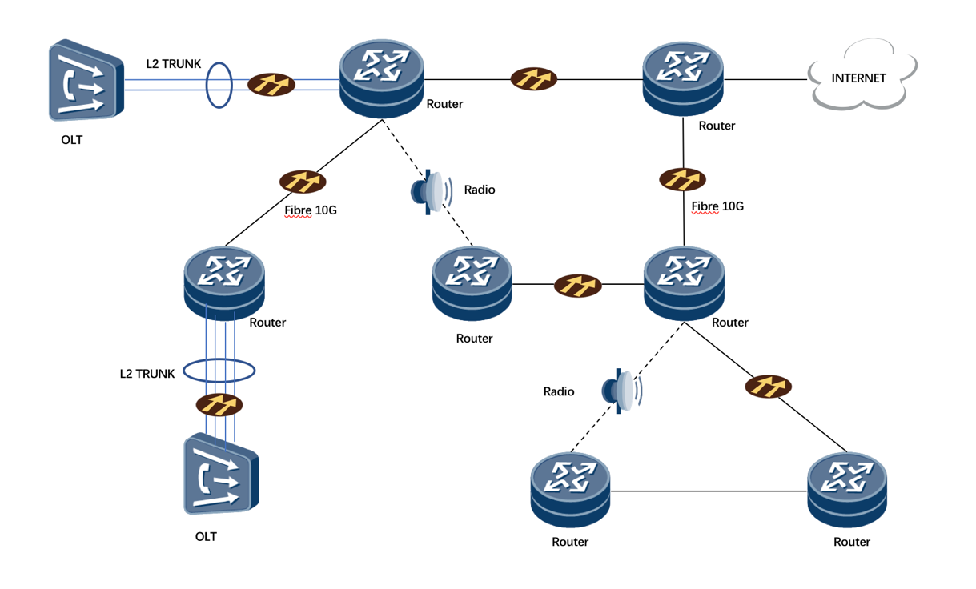

Long Term Vision:

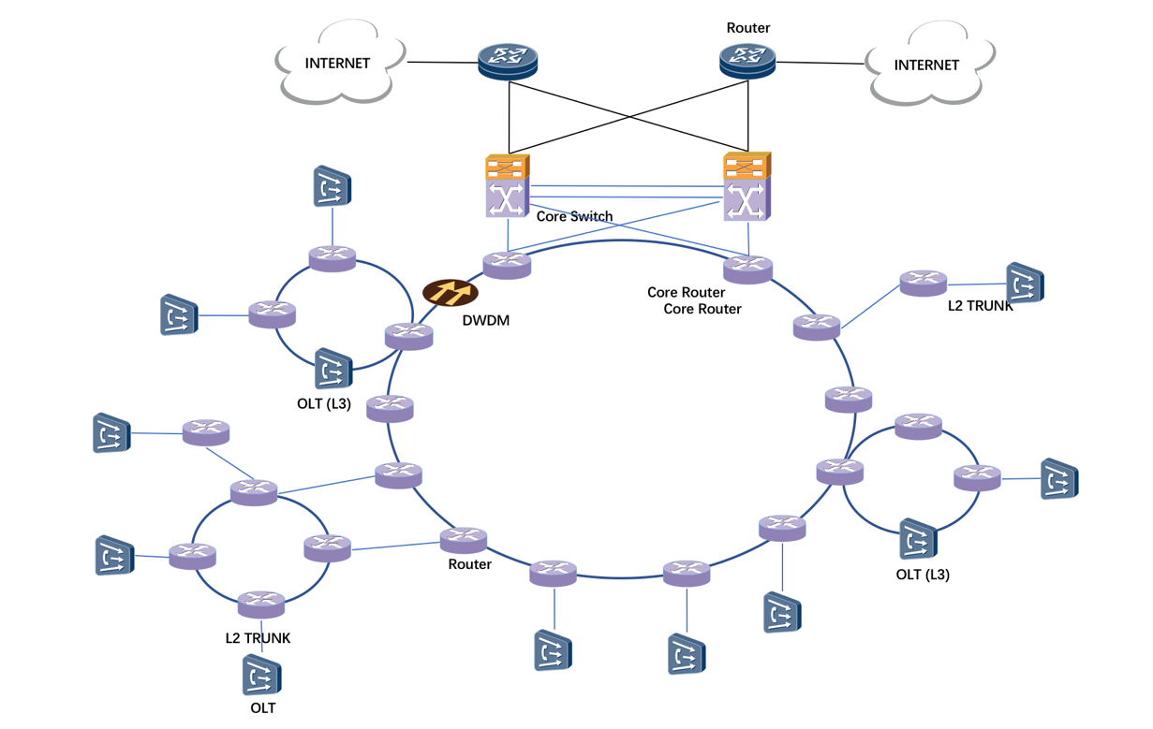

## **OLT Requirements**

### **OLT General Requirements**

The design of the proposed equipment shall be based on advanced distributed architecture and ready for future development. Please specify the architecture in detail.

The bandwidth from main control card to service slot shall be able to fulfill the requirement of multi-number users under one same OLT.

The proposed equipment shall be able to support GPON/XGS-PON/NG-PON2/CEx/P2P Ethernet(10/40/100GE). Please describe the specification including Uplink and Access.

The tender shall have three types of capacity OLT solutions, so that to fulfill different scenarios.

* Scenario A: Large capacity - (6000+ subscribers or similar)
* Scenario B: Medium capacity - (3000 subscribers or similar)
* Scenario C: Small capacity - (750 subscribers or similar)

The proposed equipment solutions offered shall comply with ITU-T G.703: Physical/electrical characteristics of hierarchical digital interface.

### **4.1.2 System Architecture**

**Redundancy**

The tender shall provide the serial OLT products to satisfy the different scenario application and the all service cards can be shared between different products.

Number of fans shall be provided, and fans redundancy shall be supported. It should not impact on system reliability if there is a fan broken.

The proposed products may have solution combine with cabinet which provide UPS and battery support to improve system availability if there is a power failure.

Control cards shall support hot standby and switch over without impact business if the main control card failure.

Considering the reliability, the proposed equipment shall support the link aggregation between different uplink cards in any service slots.

The proposed equipment shall support ISSU(In service software upgrade) for main control cards and service boards, all ONTs are always online during upgrading.

The OLT device should support automatically synchronization of configuration data after replacing a backup main board.

The OLT device should support 1588V2 and 1588ACR for clock synchronization.

The OLT device should support LACP groups.

### **4.1.3** **Capacity & Performance**

* Please describe the specification in 3 sections corresponding 3 different scenarios:

Scenario A, B, C

Numbers of ports supported in each of the scenario.

Capacity of uplink/ access, performance of the system and per port;

* Support of different line cards and numbers of ports.
* Throughput per board with per main control card.
* Performance if fully loaded for large-scale deployment.
* Line rate for upstream/downstream (GE/2.5G/10G).

The MAX power consumption of each PON port and total power requirement for the scenario;

If the solution includes combined cabinet, the battery specification and if it suitable for UK climate;

Environmental controls, if the system providing options to monitoring environmental status including power supply, temperature, fans, door and etc.

Footprint per scenario;

The proposed equipment shall be able to run IPv4/IPv6/MPLS, and the discrepancies for IPv4/IPv6/MPLS;

International Standards supported for synchronization, must support NTP over IPv6;

The function of DBA (Dynamic Bandwidth Allocation) optimization;

Be able to inspect and isolate the rogue (continuous lighting) ONT in real time and have the capability to measure the optical power.

If the OLT support embedded OTDR(eOTDR) optical module to do OTDR testing online, without influence of service.

If the OLT support the maximum differential reach (as defined on ITU-T G.984.7) of GPON extend to 40km

If the OLT support Type B switchover time less than 50 ms with 1:64 splitter and 64 ONTs.

If the OLT support more than 6dBm emission optical power of GPON optical module (SFP), and receive sensitivity should better than -35dBm, which could be fit for the bad ODN or long reach distance scenario.

### 4.1.5 L2 Functions

The proposed equipment shall support MPLS basic functions, which includes: RSVP-TE；PHP；MPLS OAM；PW Redundancy

Please describe the support of following L2 features:

VLAN;

Q-in-Q;

MAC address limitation;

PPPoE;

### 4.1.6 L3 Functions

Routing protocols: Indicate if the equipment carries out routing functions: For IPv4 Dynamic routing, the maximum number of route entry is no less than 64K. For IPv6 Dynamic routing, the maximum number of route entry is no less than 16K;

Please describe if the proposed equipment supports the following L3 features and how:

IPv4/IPv6 parity;

DHCP/DHCPv6 PD;

Routing protocols: ISIS/BGP/OSPF/OSPFv3/Static routing/RIPv2;

Routing policy/ACL;

Aggregation;

IP forwarding

GRE function/L2TP/VPLS;

LDP/RSVP-TE/SR;

MPLS forwarding/MPLS L3VPN function;

BFD;

IPv4/IPv6 ACL (if performance impact);

### 4.1.7 QOS

The OLT device should provide QOS mechanism for different services, VOIP, Video, data, etc.

The OLT shall support various quality of services (QoS) and traffic prioritization for service differentiation. The mechanism of QoS and traffic prioritization in every part (OLT, ONT, etc) of the proposed equipment shall be explained in detail.

Trusted connectivity where the QoS setting/traffic prioritization configured by customer can be preserved.

Un-trusted connectivity where the QoS setting, traffic prioritization configured by customer can be overwritten by the proposed equipment.

Please detail Downstream and Upstream QoS and traffic prioritization mechanism supporting inclusive of the hardware queue available for each direction. A minimum of 4 hardware queues shall be supported at both directions. The OLT shall implement some scheduling mechanism to manage the hardware queue such as PQ, WRR, PQ+WRR, etc..

The proposed equipment shall support traffic classification, traffic streams;

### 4.1.8 Multicast Functions

Please indicate the maximum number of multicast subscribers that can be supported by the GPON system.

The proposed equipment shall support multicast SCB feature.

The proposed equipment shall support multicast MCM feature.

The proposed equipment shall support IGMP multicast packet processing capability no less than 8000 pps

The proposed equipment shall support VMOS function.

### 4.1.9 Access and Subscriber Management Functions

* The proposed equipment shall support burst traffic detection.
* In order to improve the efficiency for security in live network, the proposed equipment shall support to configure the following management and security options
  + TR069;
  + DHCP Option82;
  + SNMP;
  + SSH;
  + Telnet;
  + NTP;
  + SFTP;
  + NETCONFG;
  + Syslog ;

## Router Requirements

## ONT Requirements